GIT Setup.

Step 1: Authenticate Yourself and Your Machine

1. ssh-keygen -t rsa -b 4096 -C [jitendra9.kumar9@cognizant.com](mailto:jitendra9.kumar9@cognizant.com)
2. eval "$(ssh-agent -s)"
3. ssh-add C:/Users/Facadmin/.ssh/id_rsa

Step 2: Add the Key to Your Github Account

1. cat C:/Users/Facadmin/.ssh/id_rsa.pub | clip
2. Under Personal settings, select “SSH and GPG keys” create and paste SSH key

Step 3: Create a Github Repository

Step 4: Clone Your Repository

1. Go to your Git hub repo- and copy the SSH key to clone the repo in your local system.

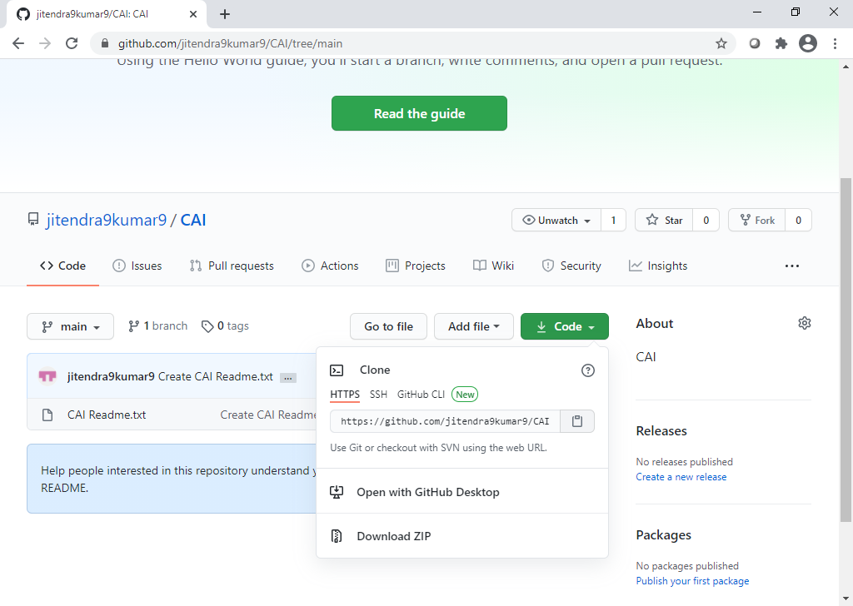

1. Run command in GIT BASH. $ git clone https://github.com/jitendra9kumar9/CAI.git
2. Add your file- $ git add filename.txt

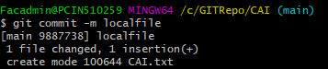

1. $ git commit -m localfile
2. $ git push- push the changes to Github. Enter credentials and click on OK in next window for authorization.

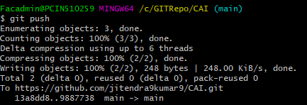

Jenkins Setup